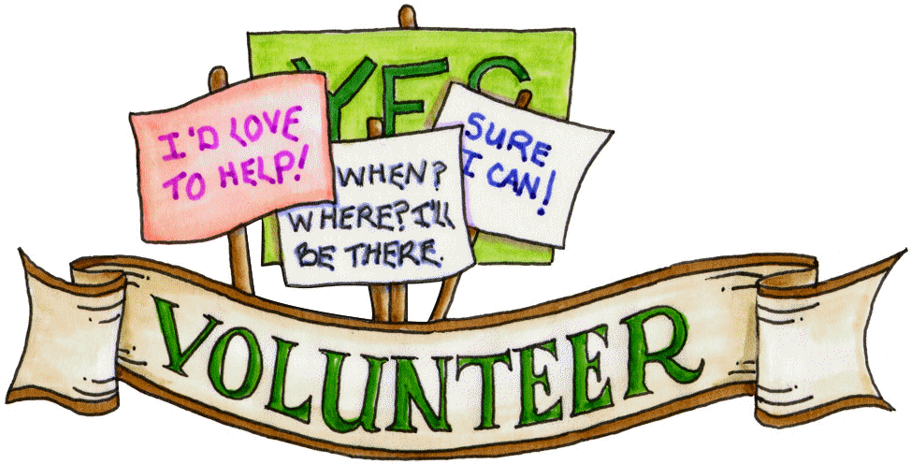
Cherokee Elementary PTA
Volunteer Opportunities 2018-2019
Interested in volunteering? We have an opportunity for you! Complete this form and return it to your child’s teacher. Listed below are just some of the programs that could use your help this year. Mark each area of interest and a fellow volunteer will contact you with more information.
Questions? Contact Jennifer Collier (anim611@yahoo.com) or Rachel Gollahon (ross0204@yahoo.com) VP of Volunteers.

Together we can make a significant contribution to our children and our school!

Volunteer Name:____________________________________ Phone:______________
E-Mail:___________________________________________ Cell #:______________
Student Name:___________________________________ Teacher:______________
- Contact me when help is needed for any program and I’ll check my schedule
or:
I would like to participate in the volunteer opportunities indicated below. Please contact me with more information.
- Copy Room
- Media Center Helper
- Conference Night Dinners for Staff (setup/cleanup/donate food)
- CheetahFest
- CheetahWalk
- Field Day
- STEAM Museum
- Thanksgiving & Grandparents Lunch
- Sixth Grade Recognition Events
- Staff Appreciation Week & Snack Cart
- Yearbook Committee (volunteer to take pictures at events)
- Vision & Hearing Screenings
- Picture Day
- Box Tops (send in/count)
- Family Events: Niederman Night, Trunk or Treat, Taste of Cherokee, Pages and Pages, Cool Critters
- Art Show
- School Beautification
- Comments/Questions_________________________________________________

