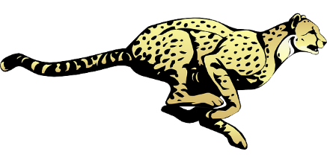
Cherokee Elementary Events
2017-2018

August
August 10 – Back to School Bash 6-8 PM
August 15 – Open House 1-3 PM
August 16 – First Day of School
August 22– PTA Meeting at 6:30 PM
August 23– The Twist Ice Cream Social 5-8 PM
August 28 – Curriculum Night (3rd/4th/5th/Gifted)
August 30 – Curriculum Night (2nd & 6th)
August 31 – Bus Driver Breakfast

September
September 11 – Culver’s (Monroe) Fundraiser
September 15 – Picture Day
September 18 – Chipotle (Bridgewater) 4-8 PM
September 20 – PTA Meeting at 9:45 AM
September 26 – Niederman Farm Night 6-8:30 PM

October
October 9-13 – Scholastic Book Fair
October 10 – Pages and Paws (6-8 PM)
October 12 – Conferences 4:30-8 PM
October 18 – PTA Meeting at 9:45 AM
October 19 – Conferences 4:30-8 PM
October 20 – Trunk or Treat 6-7:30 PM
October 25 – Picture Retakes
October 25 – Pizzeria Locale (Mason) 4-9 PM
October 26 – Conferences 4:30-8 PM

November
November 3 – CheetahFest 5:30-8:30 PM
November 6 – Raising Canes (VOA) 4-9 PM
November 16 – Thanksgiving Lunch
November 28 – PTA Meeting at 6:30 PM

December
December 8 – Dinner and a Movie
December 11 – Chick-fil-A (Bridgewater) 5-8 PM

January
January 9 – Family Skate Night 6:30 – 8:30 PM
January 17 – PTA Meeting 9:45 AM
January 25 – Conference Night 4:30-8 PM

February
February 8 – Social 6:00-7:30 PM
February 12 – Dewey’s Pizza (West Chester) 4-9 PM
February 20 – PTA Meeting at 6:30 PM

March
March 9 – Grandparents Lunch
March 9 – Dinner and a Movie
March 9-15 – Scholastic Book Fair
March 14 – Art Show 4-6:00 PM
March 16 – Spring Pictures
March 17 – Shamrock Shuffle
March 19 – Rusty Bucket (Liberty Center) 4-9 PM
March 21 – PTA Meeting 9:45 AM
March 24 – April 2 – Spring Break

April
April 9 – BW3s Restaurant Night (Bridgewater)
April 17 – PTA Meeting 6:30 PM
April 27 – CheetahWalk

May
May 7-11 – Staff Appreciation Week
May 11 – VIP Event (tentative)
May 14 – The Twist Ice Cream Social 5-8 PM
May 16 – PTA Meeting at 9:45 AM
May 22 – 6th Grade Recognition (tentative)
May 23 – Last Day of School

